**Assignment 4.1**

**Problem Statement 1:**

Write a Python Program(with class concepts) to find the area of the triangle using the below

formula.

**area = (s*(s-a)*(s-b)*(s-c)) ** 0.5**

Function to take the length of the sides of triangle from user should be defined in the parent

class and function to calculate the area should be defined in subclass.

**Solution:**

class Shape(object):

def __init__(self,s1,s2,s3):

self.s1=s1

self.s2=s2

self.s3=s3

class Triangle1(Shape):

def __init__ (self, s1,s2,s3):

super(Triangle1,self).__init__(s1,s2,s3)

def getperimeter(self):

return ((self.s1 + self.s2 + self.s3)/2)

def getArea(self):

s=self.getperimeter()

area = (s * (s - self.s1) * (s-self.s2)* (s-self.s3))/2

return (area)

area_of_triangle = Triangle1(2,2,3)

print (area_of_triangle.getperimeter())

print (area_of_triangle.getArea())

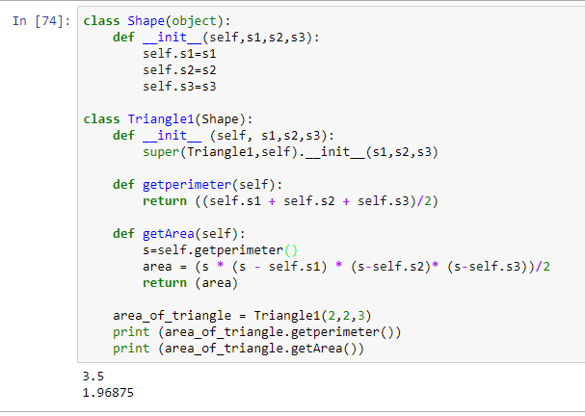

**Problem Statement​ ​2:**

[Write a function filter_long_words() that takes a list of words and an integer n and returns the list of words that are longer than n](https://stackoverflow.com/questions/21588856/write-a-function-filter-long-words-that-takes-a-list-of-words-and-an-integer-n).

**ANS:**

def filter_long_words(l,a):

words=[]

for j in l:

if(len(j)>=a):

words.append(j)

return words

n = input("Enter words:")

nt = n.split(",")

na = input("Enter Min Length:")

long = filter_long_words(nt,int(na))

print("Words with at least min length:",long)

